**Citizen AI – Intelligent Citizen Engagement Platform**

---------------------------------------------------------------------- **Team ID:** LTVIP2025TMID33533

**INTRODUCTION:**

Citizen AI is an intelligent citizen engagement platform designed to revolutionize how governments interact with the public. Leveraging Flask, IBM Granite models, and IBM Watson, Citizen AI provides real-time, AI-driven responses to citizen inquiries regarding government services, policies, and civic issues.

It integrates Natural Language Processing (NLP) and sentiment analysis to assess public sentiment, track emerging issues, and generate actionable insights. The analytics dashboard offers real-time visualizations, helping policymakers enhance service delivery and transparency. By automating routine interactions and enabling data-driven governance, Citizen AI improves citizen satisfaction, efficiency, and trust in digital governance.

**KEY SCENARIOS:**

**Scenario 1: Real-Time Conversational AI Assistant**

* Acts as the primary citizen interface.
* Built with Flask and powered by IBM Granite.
* Captures and processes user queries in real-time.
* Delivers natural, human-like AI responses.
* Supports 24/7 query handling, including issue reporting.
* Improves accessibility and civic participation.

**Scenario 2: Citizen Sentiment Analysis**

* Analyses submitted citizen feedback.
* Uses a sentiment model (e.g., Hugging Face pipeline) to classify as Positive, Neutral, or Negative.
* Highlights areas of concern or satisfaction.
* Aggregates data to provide an overall mood index.
* Visualized in the dashboard for easy monitoring.
* Helps identify public sentiment trends and service gaps.

**Scenario 3: Dynamic Dashboard**

* Centralized hub for visual insights.
* Displays citizen sentiment distribution and trends.
* Tracks peak interaction times.
* Can show service ratings and reported issues.
* Aids departments in making data-driven decisions.
* Built using charting libraries for clear data presentation.

**Scenario 4: Personalized & Contextual Response System**

* Enhances the assistant’s intelligence using IBM Granite.
* Understands user-specific context and query nuances.
* Delivers tailored responses to individual queries.
* Goes beyond generic Q&A to provide smart interaction.
* Makes civic data and service information more accessible.

**TECHNICAL ARCHITECTURE:**

**Frontend:**

* HTML/CSS/JavaScript
* Bootstrap (for responsiveness)
* AJAX for asynchronous communication

**Backend:**

* Flask (Python web framework)
* IBM Granite (for AI text generation)
* Hugging Face Transformers (for sentiment analysis)

**Models Used:**

* IBM Granite (Contextual AI assistant)
* DistilBERT (Sentiment analysis via Hugging Face)

**Dashboard Tools:**

* Chart.js or Plotly.js
* Templates using Jinja2 for dynamic data

**Data Handling:**

* User queries and feedback stored in JSON or database
* Feedback analyzed and classified
* Results fed to dashboard charts in real-time

| **Component** | **Technology** |
| --- | --- |
| Frontend | HTML, CSS, Bootstrap, JavaScript |
| Backend | Python (Flask) |
| AI Models | IBM Granite, Hugging Face Transformers (DistilBERT) |
| Visualization | Chart.js, Plotly.js |
| Database | JSON / SQLite / MongoDB (Optional) |

**PROJECT FLOW:**

1. **User Interaction:** Citizens type queries via the interface.
2. **Real-Time Response:** Query sent to Flask backend -> IBM Granite model processes and replies.
3. **Feedback Collection:** Optional sentiment feedback is stored.
4. **Sentiment Analysis:** Backend function classifies input sentiment.
5. **Data Aggregation:** Results stored and prepared for dashboard.
6. **Dashboard Visualization:** Admin views real-time stats (sentiment ratios, volume, trends).

**ER DIAGRAM (Logical Description):**

**Entities:**

* User: user_id, name, email, role
* Query: query_id, user_id, text, response, timestamp
* Feedback: feedback_id, user_id, sentiment, message, timestamp
* Admin: admin_id, email, password

**Relationships:**

* A User can make many Queries
* A User can submit many Feedback entries
* Admin monitors Queries and Feedback

**OUTPUTS:**

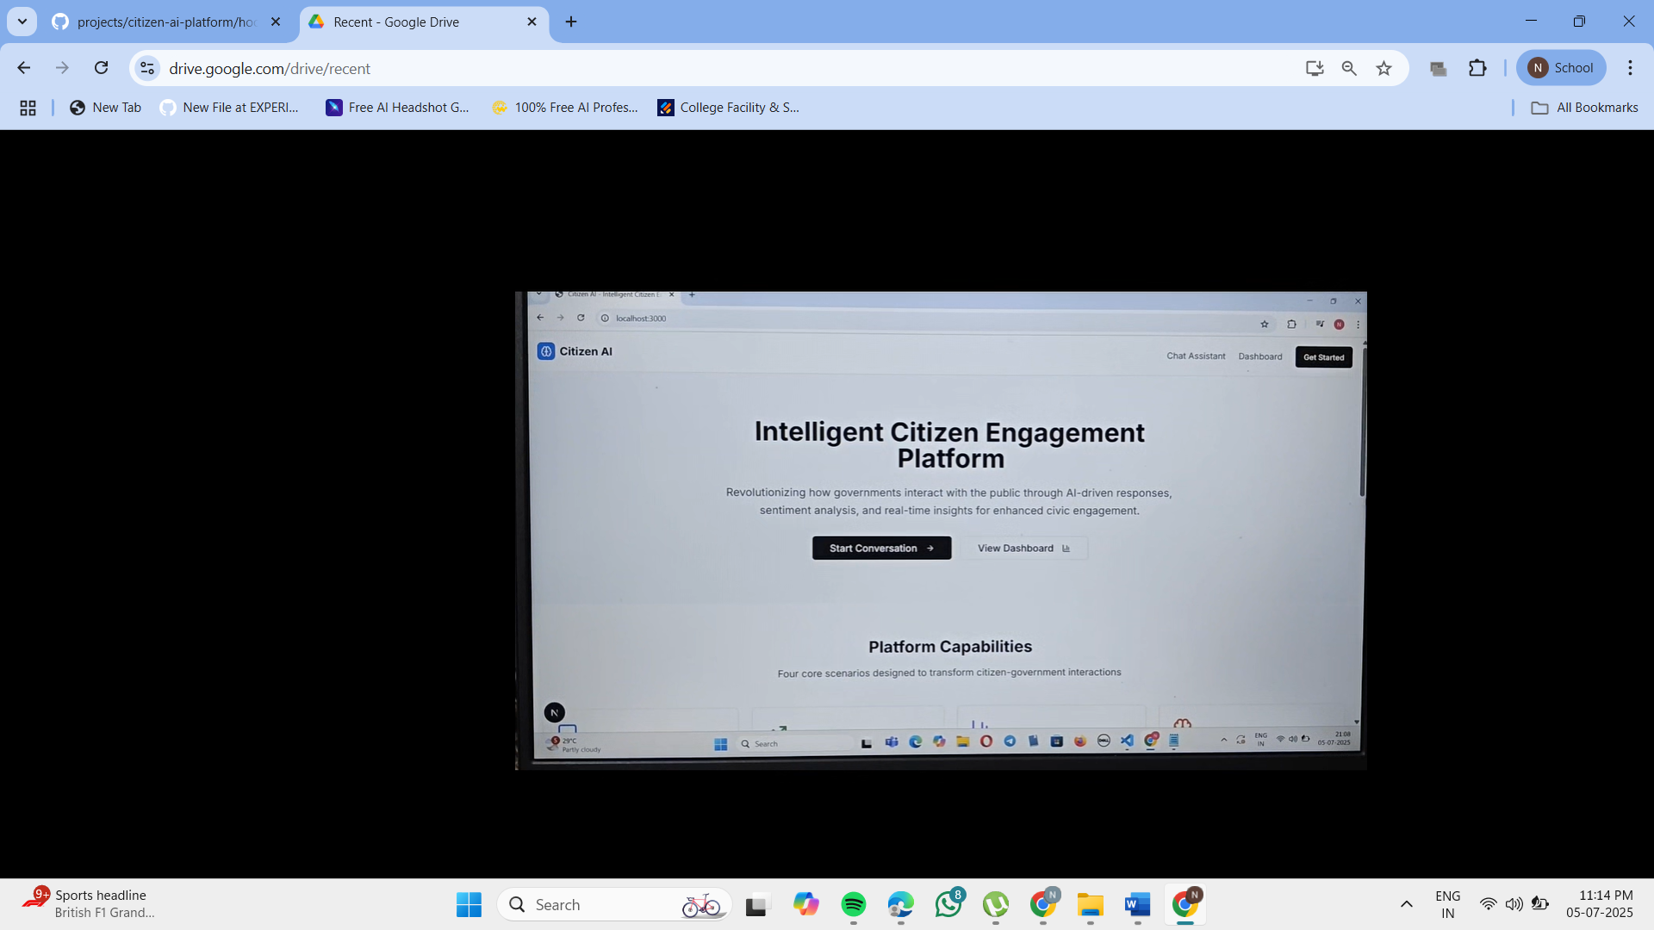

**Fig 1**:Home page of the application

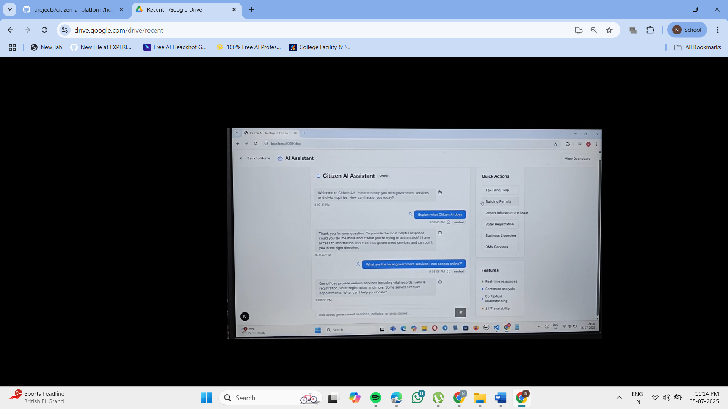

**Fig 2**: Real-Time Conversational AI Assistant

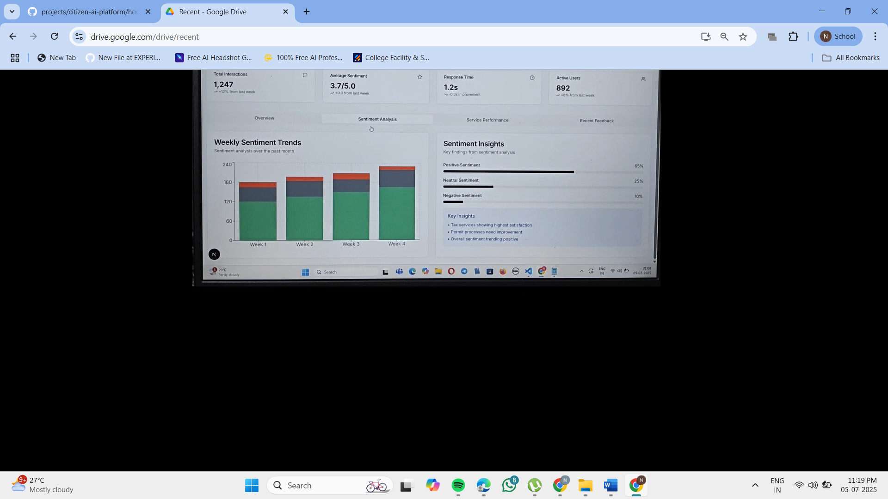

**Fig 3:** Citizen Sentiment Analysis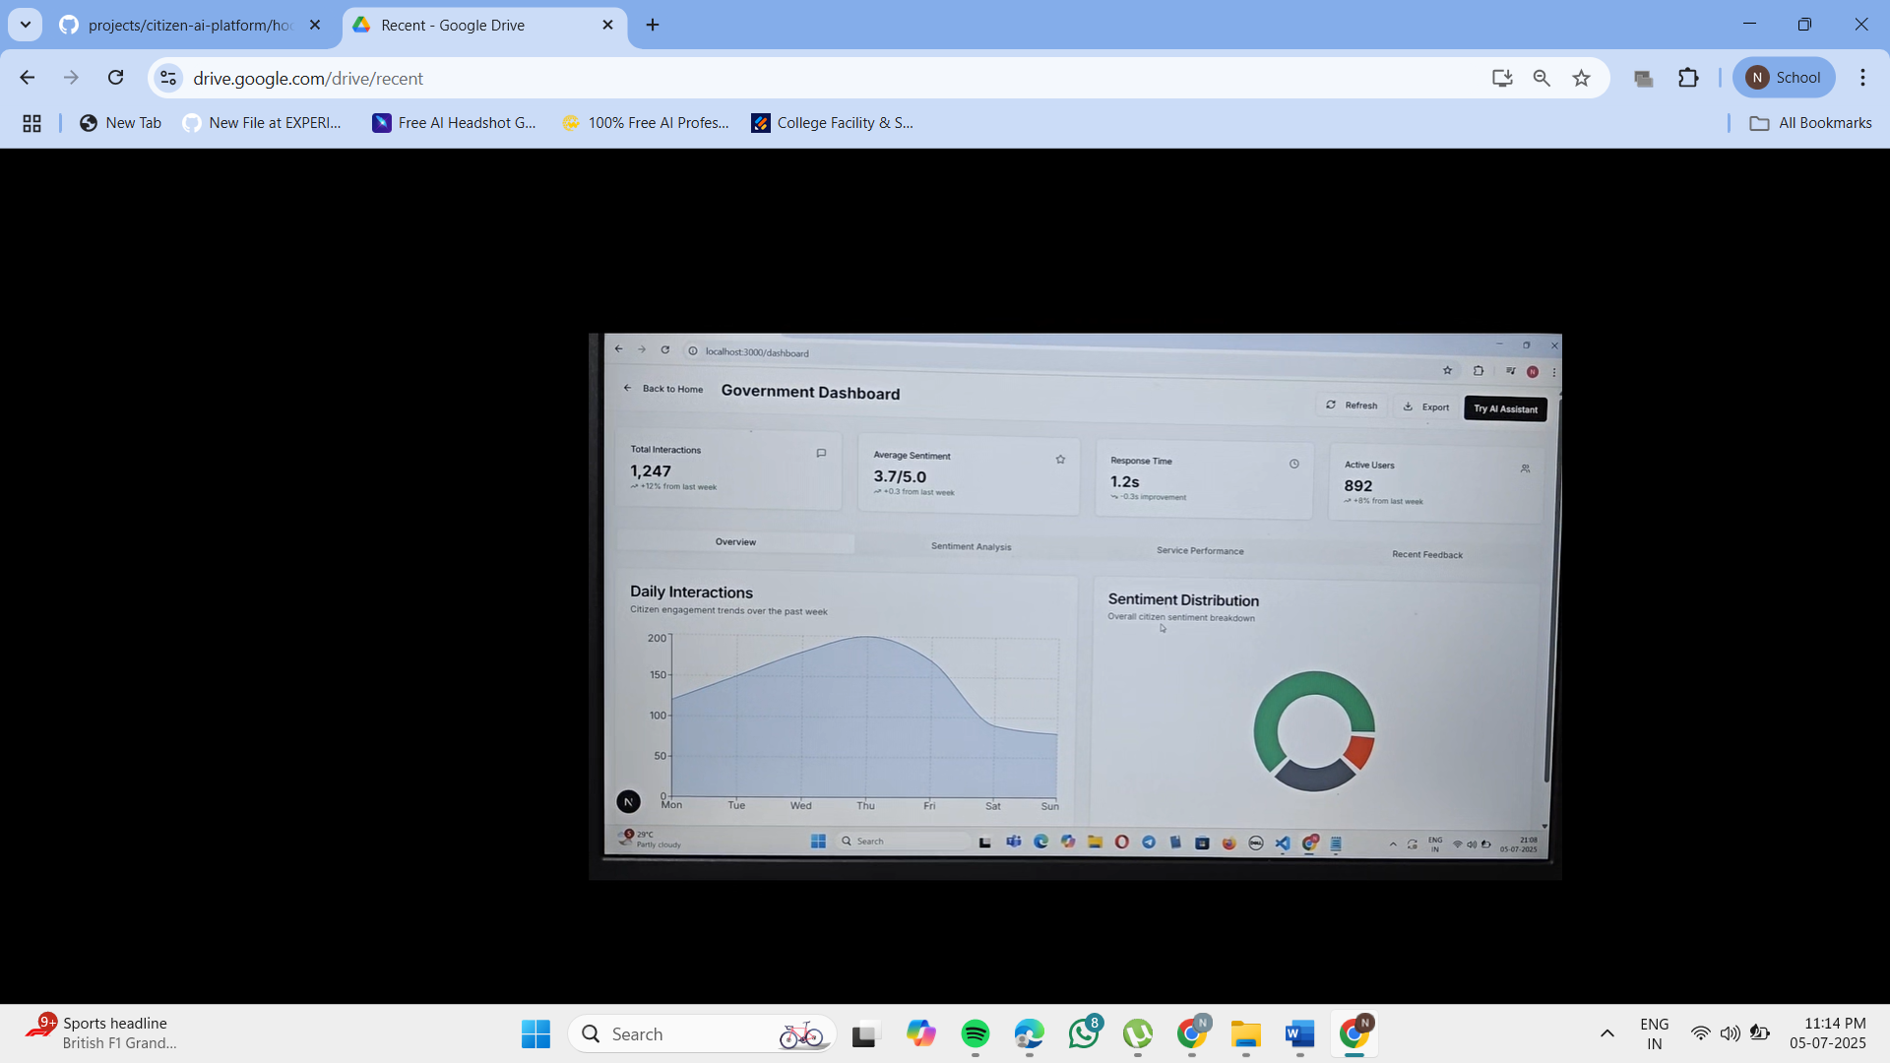

**Fig 4:** Dynamic Dashboard

**DEMO LINK:**

[**Click here to view the demo**](https://drive.google.com/file/d/1EUDoDkP_N3SpSoPU9vYDj6kQiKghqK4Q/view?usp=drive_link)

**GITHUB LINK:**

[**click here to open the repository**](https://github.com/nivedithakummetha63/projects/tree/main/citizen-ai-platform)

**TEAM MEMBERS:**

|  |  |
| --- | --- |
| **Role** | **Name** |
| Developer,Team Lead | R. Likhitha |
| Developer,Designer | Neha Anjum D |
| Tester | B. Keerthi |
| Quality Analyst | Pallavi Kummara |
| Deployment | K. Niveditha |

**CONCLUSION:** Citizen AI transforms public service access and governance by combining AI, sentiment analysis, and real-time interactivity. Its modular design and intuitive features create a scalable solution for intelligent citizen engagement, enabling governments to respond smarter, faster, and more transparently.